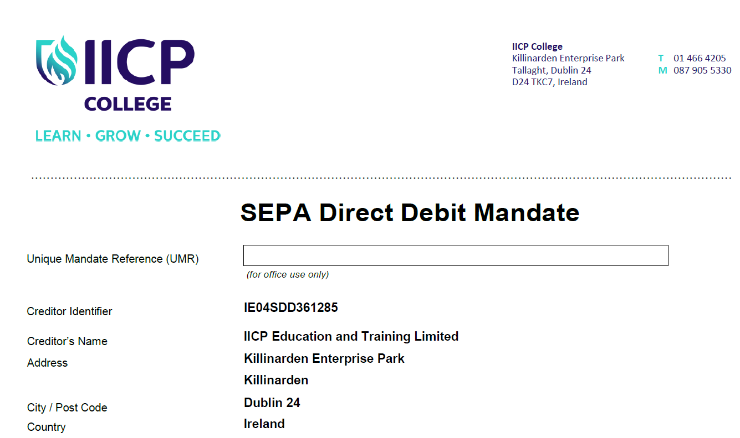
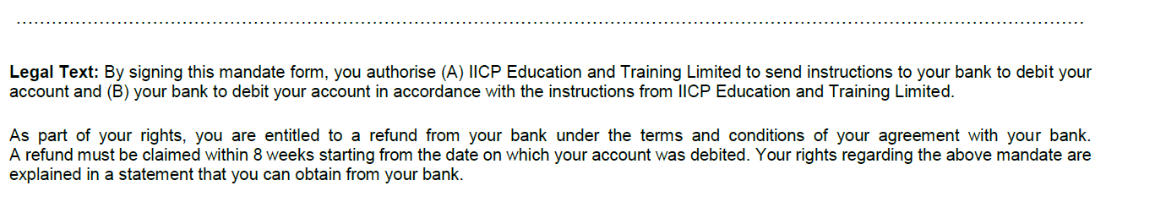
Please complete all the forms marked*
Your Name

Your Address
Your City / Postcode
Your Country

Your IBAN Number (22 characters) *

Your BIC / SWIFT Number*

Type of Payment* | Recurrent Payment |  | Or one-off payment |  | Please tick one box only

Date of Signature*

Signature*

